Aim:

Shell Script to check whether a given file is directory or not, to count no. of files in directory, to copy file content to another.

Code:

**#!/bin/bash**

**echo "Enter File Name:" read dir**

**if [ -d $dir ] then**

**echo -n 'Given File Name: "' echo -n $dir**

**echo -e '" is a Directory.' elif [ -f $dir**

**]**

**then**

**echo -n 'Given File Name: "' echo -n $dir**

**echo -e '" is not a Directory, but present as a File.' else echo -n 'Given "'**

**echo -n $dir**

**echo -e '" is not a File.' fi**

Output**:**

Aim:

Write a grep script to find the number of words character, words and lines in a file.

Code:

**echo Enter The Filename:**

**read file**

**if [ ! -f $file ] then**

**echo -e "File $file Does Not Exist." exit else echo File Exist.**

**fi**

**w=`cat $file | wc -w` c=`cat $file | wc -c` l=`grep -c "." $file`**

**echo -e "\nNumber of Characters in $file is $c"**

**echo Number of Words in $file is $w echo Number of Lines in $file is $l echo -e "\nThe Content of File:"**

**cat $file echo -e "\n"**

Output:

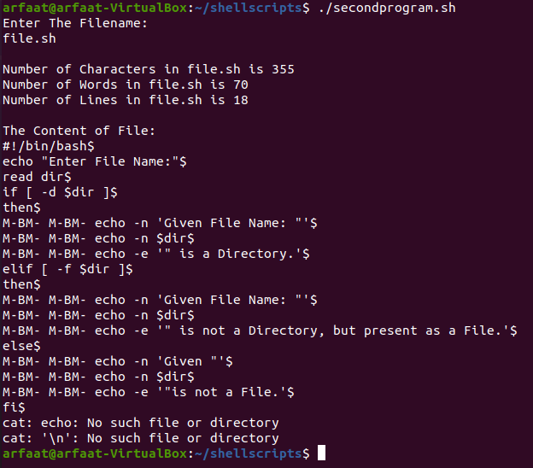

AIM : Write a Shell script that displays list of all the files in the current directory to which the user has read, write and execute permissions.?

THEORY: Cd: The cd command can be used for to change the directory that means we can change the existing directory.

Wc: The wc command can be used for to count the number of words on given data by using wc command options we can count the number of lines on a file (wc-l).

CODE :

**#!/bin/bash**

**echo "The name of all files having all permissions :" for file in \***

**do**

**if [ -f $file ]**

**then**

**if [ -r $file -a -w $file -a -x $file ] then**

**ls -l $file fi**

**fi done**

OUTPUT :

AIM :

Write a shell script to list all of the directory files in a directory.

CODE :

**#!/bin/bash**

**echo "Enter directory name" read dir**

**if [ -d $dir ] then**

**echo "List of files in the directory" ls -al $dir|egrep '^d'**

**else**

**echo "Enter proper directory name" fi**

OUTPUT :

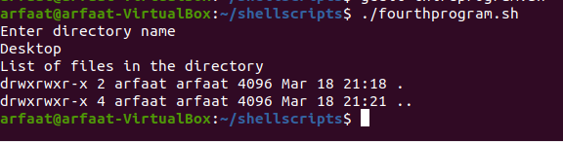

AIM :

Write a Shell script that accepts a filename, starting and ending line numbers as arguments and displays all the lines between the given line numbers?

THEORY:

Cat: cat command is used to create the file Syntax: cat > file name for creation Syntax: cat file name for displaying a file Sed: sed means stream editor it can be used for editing the main program by using sed

echo "enter the filename" read fname echo "enter the starting line number" read s echo "enter the ending line number" read n sed -n

$s,$n\p $fname | cat > newline cat newline

CODE :

**#!/bin/bash**

**echo "enter the filename" read fname**

**echo "enter the starting line number" read s**

**echo "enter the ending line number" read n**

**sed -n $s,$n\p $fname | cat > newline cat newline**

OUTPUT :

